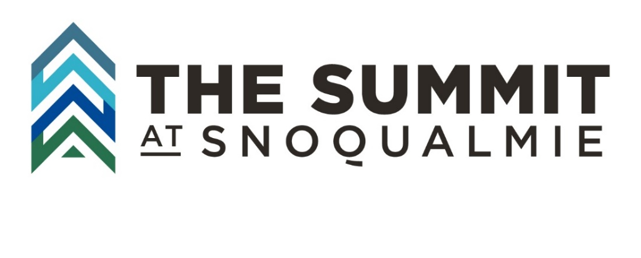
Summit at Snoqualmie Spring 2022 Corporate Discount
Use your unique company promo code to access an additional 10% off select online advanced lift ticket reservations at the Summit at Snoqualmie this spring!
- Company: SCCA- The Whole U
- Spring 2022 Promo Code: WholeUSpring22
Who is eligible: Offers available for member employees, employee dependents, and employee spouse/domestic partners.
Remember – You must provide proof of employment when redeeming reservations at the ticket window.

Acceptable Forms of Employee ID Membership ID
Examples include:
- employee ID card
- employee email
- letters from supervisors/HR on company letterhead
- employee pay stub
Acceptable membership ID
- physical or digital Passport membership card
- physical or digital PRIME membership card.
Photos/screenshots of any of the above items on mobile devices are fine.
Discounts are not available on transactions completed without using the promocode prior to or after launch of promotions and will not be applied retroactively.
Please note that discounts are only available for tickets purchased using the promo code. Discounts are offered on select ticket options. We will not apply a corporate discount retroactively to tickets purchased prior to or after program launch when the transaction has been completed without using the promo code. Tickets must be purchased using the promo code from available online inventory to receive the discount offer. Discounts are not available onsite.
How to reserve and redeem
Go to https://summitatsnoqualmie.com/lift-tickets
Click on any of the shop now buttons or go directly to https://summitatsnoqualmie.com/lift-tickets?keyword=LiftTickets
To Access your discount offers on select tickets click on the Promo Code tab:
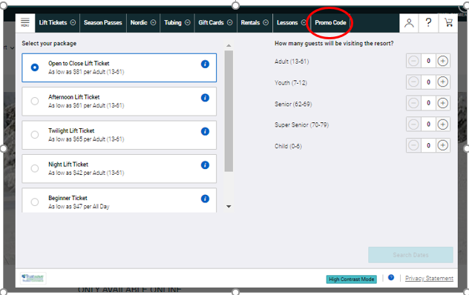
Enter your promo code in the promo code box and then click on submit
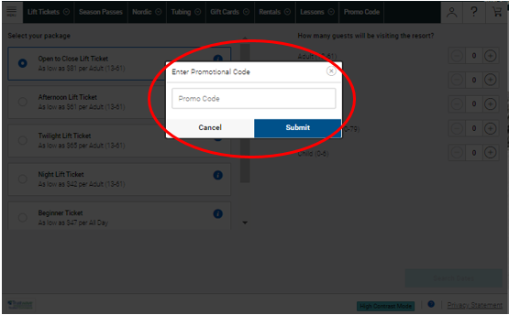
You will then see the select tickets available with your corporate discount
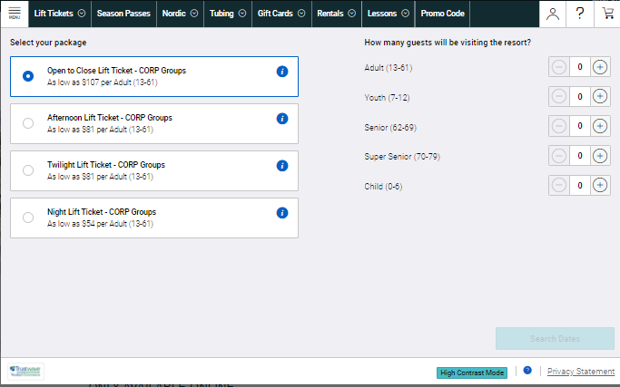
Select the number of tickets you want to purchase by age group and click on select date
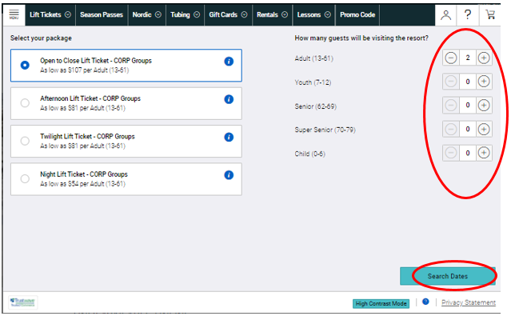
Select a date that tickets are available and click on add to cart
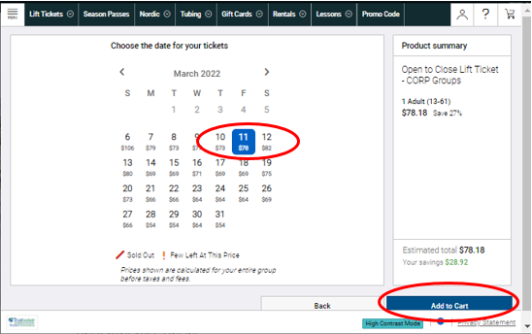

Click on the button to agree to the terms and conditions then click next.
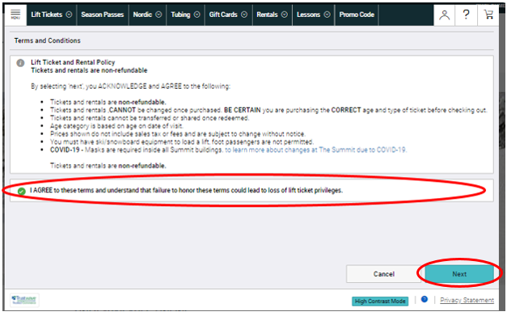
At this point, you can opt to add rentals by clicking on more info if you would like (No additional discounts on rentals or any other products added to the transaction. Discounts are for select lift tickets only.) or proceed to check out if you are ready to complete your transaction.
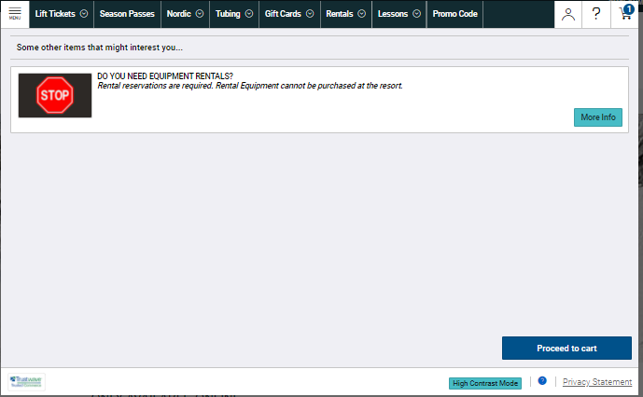
Complete your transaction.
You will receive an email with a link to your ticket vouchers. We highly recommend taking screenshots of ticket vouchers to show at the ticket window as cell reception can be spotty at the mountain.
When you redeem your vouchers at the ticket window you will be asked to show proof of employment or membership for your group in order to get vouchers redeemed for a lift ticket for the day. We will not be able to redeem vouchers for tickets without proof of employment membership
We look forward to having you on the mountain with us!

